

GCE/IAL applicable

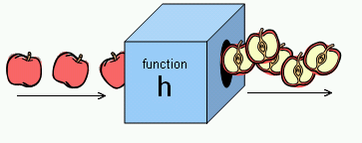 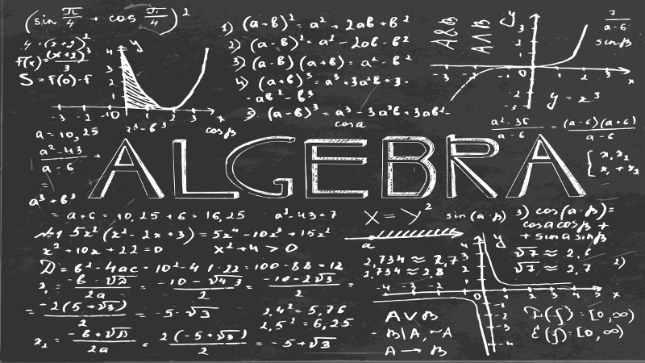

Algebra and functions

For C1(GCE)/C12(IAL)

|  |  |
| --- | --- |
| Main Concept 1: Simplify expressions and collect like terms |  |
| Main Concept 2: Apply the rules of indices |  |
| Main Concept 3: Multiply out brackets |  |
| Main Concept 4: Factorise expressions including quadratics |  |
| Main Concept 5: Manipulate surds |  |

**Content**

**Main Concept 1:**

**Simplify expressions by collecting like terms**

Definition of like terms:

For two terms to be like terms, their indices must be the same, and the corresponding variables must be the same, but the coefficients do not necessarily the same.

For example, $2x, 3x$ are like terms, $2x^{2}, 3x^{2}$ are like terms, $2xy, 3xy$ are also like terms, but $2x, 3y$ are not like terms, $2x, 3x^{2}$ are not like terms, $2xy, 3xz$ are not like terms.

|  |  |
| --- | --- |
| Like terms | Not like terms |
| $$2x, 3x$$ | $$2x, 3y$$ |
| $$2x^{2}, 3x^{2}$$ | $$2x, 3x^{2}$$ |
| $$2xy, 3xy$$ | $$2xy, 3xz$$ |

You can group the like terms together and simplify the expressions.

**Exercise 1**

$3r+7t-5r+3t$

$2\left(3x^{2}+4x+5\right)-3{(x}^{2}-2x-3)$

$\left(r^{2}+3t^{2}+9\right)-{(2r}^{2}-3t^{2}-4)$

$\left(2x^{2}+4x+10\right)-7{(x}^{2}-2x-3)$

$3m-p-n+2(4m-n+p)$

**Main Concept 2: Apply the rules of indices**

We have indices rules when applying the polynomials related to powers.

$$a^{m}×a^{n}=a^{m+n}$$

$$a^{m}÷a^{n}=a^{m-n}$$

$${{(a}^{m})}^{n}=a^{mn}$$

$${(a}^{-m})=\frac{1}{a^{m}}$$

$${(a}^{\frac{1}{m}})=\sqrt[m]{a}$$

$$a^{0}=1$$

Remember to group the like terms and then perform index law.

**Exercise 2**

Simplify the following expressions

$x^{m}×x^{n}$

$5^{m}×{25}^{n}$

${2y}^{m}×3y^{n}$

$a^{m}×a^{n}$

$b^{m}÷a^{m}$

${6x}^{-4}÷{3x}^{-5}$

${{[6(x}^{-4})]}^{2}×{2x}^{-5}$

${({3x}^{3})}^{3}÷{(3x)}^{3}$

${[3(x}^{3})]×(x^{4})$

**Main Concept 3: Expand and factorize the terms outside**

There exist some algebra techniques which is very useful, both in C1 and the further units. They could help you to make the answers clearer.

They are the ability to expansion and factorization of the terms.

Given an expression $a\left(bx+c\right)$, we can expand it into $abx+ac$.

Given an expression $abx+ac$, we can factorize it into $a\left(bx+c\right)$.

For example, for $5\left(2x+3\right)=10x+15$, and vice versa.

Note: $a$ does not necessarily a constant, it could be a polynomial, an unknown, or even complex number.

**Exercise 3**

Expand and simplify the following terms

$9(x-4)$

$x(x-4)(x-3)$

$5\left(x-2\right)+6\left(x-2\right)$

$3\left(y-47\right)+2(y-8)$

$(6z-24)(3-z)$

$5m-10n$

$m^{2}-mn-6n^{2}$

$m^{2}-mn-6n^{2}-5m-10n$

${3m}^{2}(2m+1)-{5m}^{2}(3m-4)$

${3m}^{2}-\left(2m+1\right)+{5m}^{2}-(3m-4)$

$3x+9$

${6m}^{2}-18m$

${12m}^{2}n+8{mn}^{2}$

${12m}^{2}-8{mn}^{2}$

${12m}^{2}-30$

$m^{2}n-9{mn}^{2}$

${12m}^{2}-4{mn}^{}$

$m^{2}-4m$

$m^{2}-4$

**Main Concept 3 : Quadratic factorization**

We could perform quadratic factorization by many means.

Remember what we have learnt in last chapter:

$a$ does not necessarily a constant, it could be a polynomial, an unknown, or even complex number.

**Example 1**

When we try to factorize $m^{2}-m$, we can try to take out m and it becomes

$(m-0)(m-1)$, so we can deduce that a standard quadratic function could be factorize into $(m-a)(m-b)$, if possible, where a and b are arbitrary constants.

**Exercise 4**

$m^{2}-4m$

$m^{2}-6m$

${2m}^{2}+4m$

${3m}^{2}+6m$

${5m}^{2}-7m$

$m^{2}-4m$

**Example 2**

We are able to deal with the quadratic equation with form of $ax^{2}+bx+c$, where a and c are not equal to 0.

Skill 1: Recall the square identities.

$${(x+y)}^{2}=x^{2}+2xy+y^{2}$$

$${(x-y)}^{2}=x^{2}-2xy+y^{2}$$

$$x^{2}-y^{2}=(x+y)(x-y)$$

Skill 2: Divide the coefficient of x and then factorize them

For example,

$$x^{2}-5x-6$$

$=x^{2}-6x+x-6$

$$=x\left(x-6\right)+\left(x-6\right)$$

$=(x+1)(x-6$)

Then we are done.

Skill 3: use of calculators.

1. For fx-50 fh series, we switch it to comp mode, press formula 01, and input the coefficients of $x^{2}, x$ and the constant term respectively.
2. We will have a and b as roots, rewrite the function in the form of $\left(x-a\right)\left(x-b\right),$ where a and b are exactly the two roots.
3. Use reverse engineering, rewrite the function in the form of $x^{2}-ax-bx+ab$.
4. Don’t forget to write the coefficient of $x^{2}$ if it is not 1.
5. Rearrange the order of your steps.

**Exercise 5**

Factorize the following expressions:

$x^{2}-4x$

$x^{2}-11x+24$

$x^{2}-13x+40$

$x^{2}-2x-8$

${7x}^{2}-43x+6$

${2x}^{2}-50$

${4x}^{2}-4$

${7x}^{2}-343$

**Main Concept 5: Rationalization**

Please apply the concepts in main concept 2 to finish the following exercise.

**Exercise 6**

Evaluate:

$9^{\frac{1}{2}}$

${256}^{\frac{1}{3}}$

${100}^{\frac{3}{2}}$

$4^{\frac{-3}{2}}$

${(1\frac{9}{16})}^{\frac{1}{2}}$

${(\frac{343}{512})}^{\frac{-2}{3}}$

${(1\frac{9}{16})}^{-1}$

When we see something like $\sqrt{b}$, where $b={ac}^{2},$ we could take out c and express $\sqrt{b}$ in form of $c\sqrt{a}$.

**Exercise 7**

Simplify

$\sqrt{18}$

$\frac{\sqrt{105}}{3}$

$5\sqrt{18}-3\sqrt{2}+\sqrt{98}$

$\sqrt{64}$

1. 27 $\sqrt{18}$

$\sqrt{27}$

$\sqrt{150}$

Rationalization of surds

Apply $x^{2}-y^{2}=(x+y)(x-y)$ when the denominator is in form of $a±\sqrt{b}$.

**Exercise 8**

$\frac{\sqrt{32}-\sqrt{27}}{\sqrt{32}+\sqrt{27}}$

$\frac{1}{\sqrt{2}+1}$

$\frac{2}{\sqrt{3}+\sqrt{1}}$

$\frac{1}{\sqrt{32}}$

$\frac{\sqrt{32}-\sqrt{27}}{\sqrt{32}+\sqrt{27}}$